|  |  |
| --- | --- |
| Nikon D780 (Body)  Máy Ảnh Nikon D780 (Body) | Chính Hãng  Nikon D780.1 Nikon D780.2 Nikon D780.4 Nikon D780.3 | **Featured information:**  Sensor: Full-frame  ISO range: 100 - 51200 (expandable 50 - 204800)  Resolution: 24.5MP  Wireless connection: WiFi, bluetooth  Price: $ 1900  **Specifications:**  Viewfinder Type  Optical (Pentaprism)  Screen Characteristics  Tilting Touchscreen LCD  Screen Resolution  2,359,000 pixels  Screen Size  3.2"  Viewfinder Magnification  Approx. 0.7x  Viewfinder Coverage  N/A  Viewfinder Size  N/A  Viewfinder Resolution  N/A |

**Overview:**

Overall, it can be seen that the Nikon D780 has a big and bold design with many angles and buttons, looking very professional and modern. The D780 weighs only 840 grams and measures 143.5 x 115.5 x 76 mm. In particular, on this version Nikon has removed the "toad" flash that often appears on previous full-frame Nikon cameras, giving the device a more seamless and sealed design.

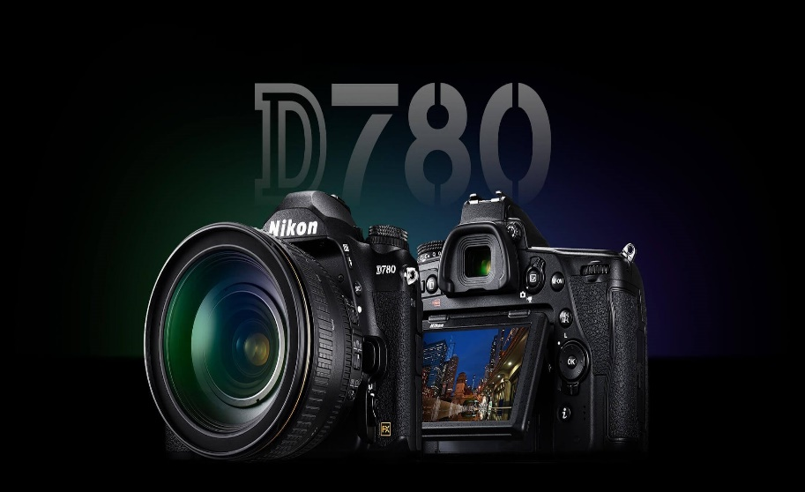

Thân máy sử dụng vật liệu hợp kim magie mang lại cảm giác nhẹ nhàng nhưng vẫn chắc chắn. **Nikon D780** cũng có khả năng chống bụi và hơi ẩm lọt vào nhờ trang bị lớp cao su tại các vị trí hở và nút bấm.

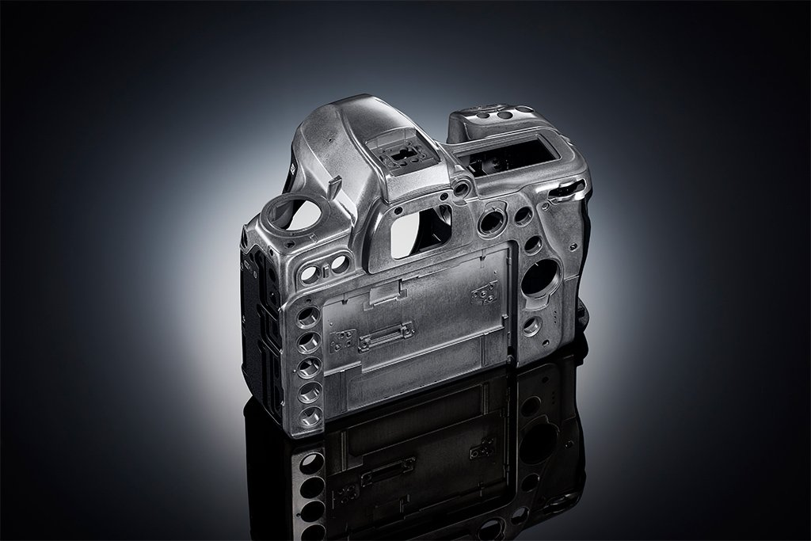

The 3.2-inch flip LCD touch screen equipped on the Nikon D780 allows users to easily take photos at high or low angles, and intuitively control the camera's parameters and change the focus point.

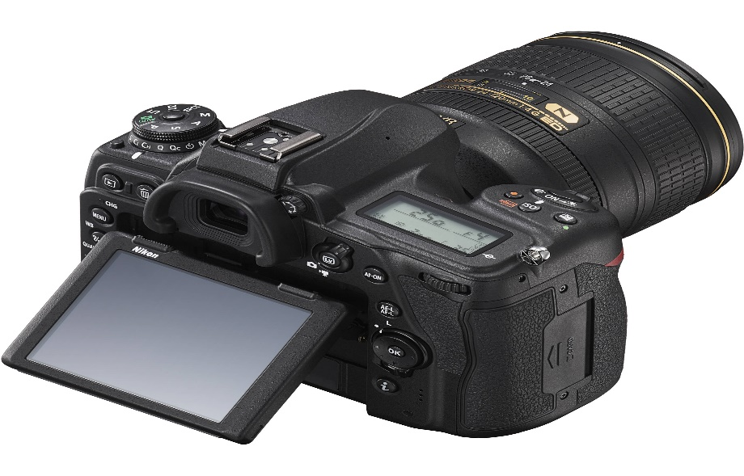

Basic connection ports for microphone, headphones, USB, control cable, and mini HDMI are still equipped on the Nikon D780. In addition, two UHS-II standard SD memory card slots provide fast data reading and writing speeds and flexibility in the file storage process. In addition, the included EN-EL15b Lithium-Ion Battery allows taking about 2260 photos per full charge.